# Overview

* A randomized event system where and predatory animals attack the farm.

# Predator System

* Randomized attacks by wild animals occur at a minimum interval of 3 in-game days.
* These attacks will increase frequently only after animal husbandry is setup.
* Seasons play a major role in deciding which animals will attach
* Predators like :
  + Bears
  + Wolves
  + Wild Cats
  + Coyote
  + Owls
  + Hawks
  + Foxes
  + Weasels
  + Snakes
* These attacks will lead to loss of animal life on farm including any pets.

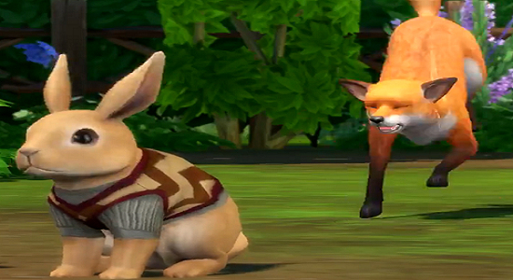

* Some farm animals and pets may even fight the predators
* The predators may attack the farmhands and the player too, but the player will only be injured and will have to visit the hospital/infirmary.
* Early warning systems like trail cameras, proper lighting and alarms can be used.
* Security measures like fences, physical barriers ,guards,etc can be installed.
* If an alarm system is in place the minimap will have a notification icon showing the location of the attack whenever there is a predator attack.
* Attacks can be stopped in between